**COS 20007**

**Task 1.2**

Duc Thuan Tran

*104330455*

1. **Code**
2. Message.cs

using System;

namespace _1._2

{

internal class Message

{

private string _text;

public Message(string text)

{

_text = text;

}

public void Print()

{

Console.WriteLine(_text);

}

}

}

1. Program.cs

namespace _1._2;

class Program

{

static void Main()

{

Message message1 = new Message("What's up Thuan, how are you?");

Message message2 = new Message("Hello Hieu,how's your day?");

Message message3 = new Message("Greetings, Nam! nice to see you!");

Message message4 = new Message("Hey Phong, good to have you here!");

Message standardmessage = new Message("Welcome new person, nice to meet you!");

Message[] messages = { message1, message2, message3, message4, standardmessage };

Console.Write("Enter your name: ");

string name = Console.ReadLine();

if (name == "thuan".ToLower())

{

messages[0].Print();

}

else if (name == "hieu".ToLower())

{

messages[1].Print();

}

else if (name == "nam".ToLower())

{

messages[2].Print();

}

else if (name == "phong".ToLower())

{

messages[3].Print();

}

else

{

messages[4].Print();

}

}

}

1. **Image**
2. Breakpoint

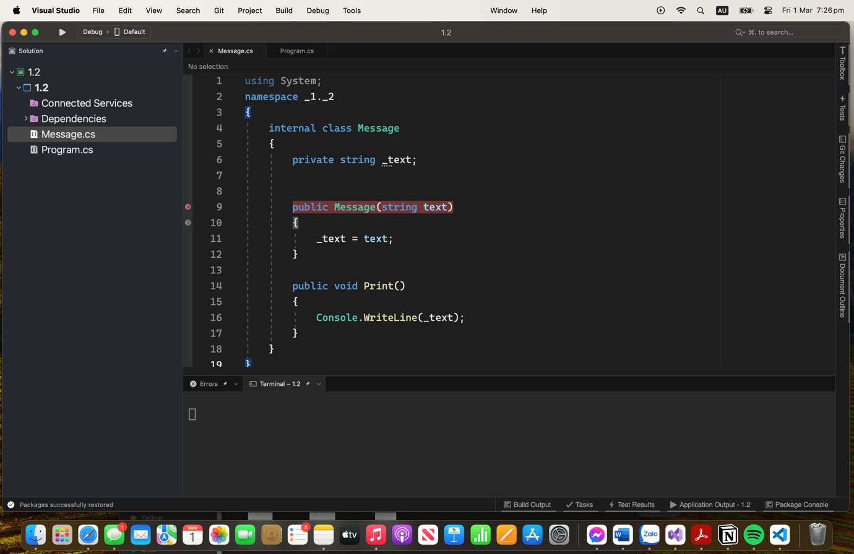

1. Debugger

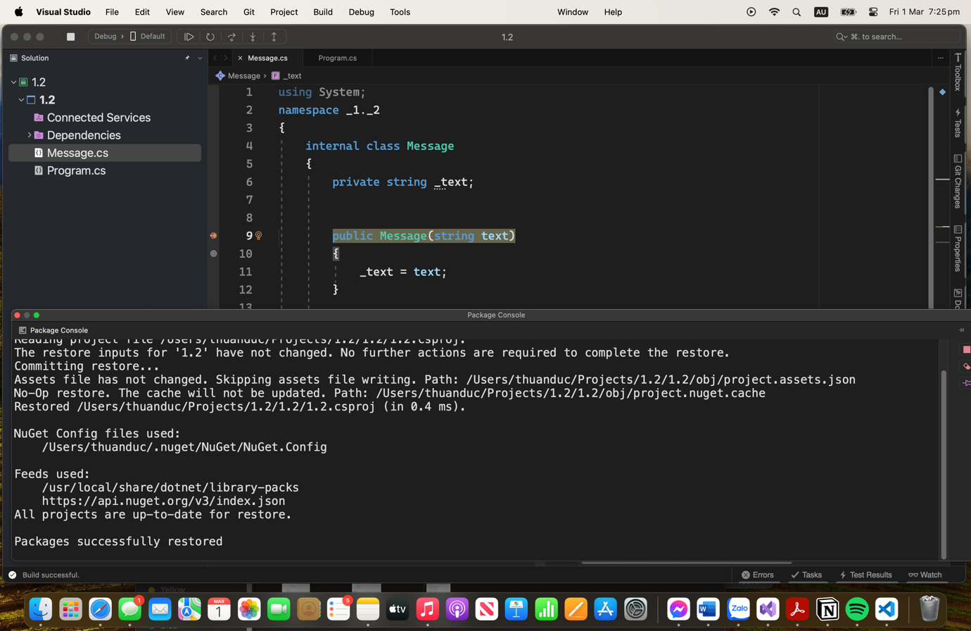

1. Program’s output

